**Python Lab Exercise 4**

Q1: Write a Program to make a simple calculator that can add, subtract, multiply and divide using functions

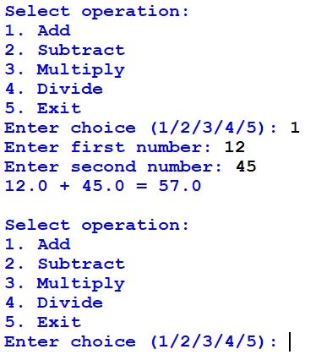

Q 2: write a Program to display the Fibonacci sequence up to n-th term where n is provided by the user

Q 3: Write a Python Program To Display Powers of 2 Using Anonymous Function

( Lambda function). Take number of terms from user

# Q 4: Write a Python Program to find numbers divisible by thirteen from a list using anonymous function

Q5: Write a Python program to display the Fibonacci sequence up to n-th term by using recursive functions

Q 6: Write a Python program to find the sum of natural numbers up to n using recursive function

Q. 7. Write a version of a palindrome recognizer that also accepts phrase palindromes such as "Go hang a salami I'm a lasagna hog.", "Was it a rat I saw?", "Step on no pets", "Sit on a potato pan, Otis", "Lisa Bonet ate no basil", "Satan, oscillate my metallic sonatas", "I roamed under it as a tired nude Maori", "Rise to vote sir", or the exclamation "Dammit, I'm mad!". Note that punctuation, capitalization, and spacing are usually ignored.

Q. 8. A pangram is a sentence that contains all the letters of the English alphabet at least once, for example: The quick brown fox jumps over the lazy dog. Your task here is to write a function to check a sentence to see if it is a pangram or not.

Q.9. Define a function overlapping() that takes two lists and returns True if they have at least one

member in common, False otherwise.

Q. 10. Write a function find_longest_word() that takes a list of words and returns the length of the longest one.

Q. 11. Write a function filter_long_words() that takes a list of words and an integer n and returns the list of words that are longer than n.